**How to install and use Docker on RHEL 7 or CentOS 7 (method 1)**

The procedure to install Docker is as follows:

1. Open the terminal application or login to the remote box using ssh command:  
   **ssh user@remote-server-name**
2. Type the following command to install Docker via yum provided by Red Hat:  
   **sudo yum install docker**
3. Type the following command to install the latest version of Docker CE (community edition):  
   **sudo yum remove docker docker-common docker-selinux docker-engine**  
   **sudo yum-config-manager --add-repo https://download.docker.com/linux/centos/docker-ce.repo**  
   **sudo yum install docker-ce**

Let us see all info in details along with examples.

**How to install Docker on CentOS 7 / RHEL 7 using yum**

Type the following [yum command](https://www.cyberciti.biz/faq/rhel-centos-fedora-linux-yum-command-howto/):  
$ sudo yum install docker  
[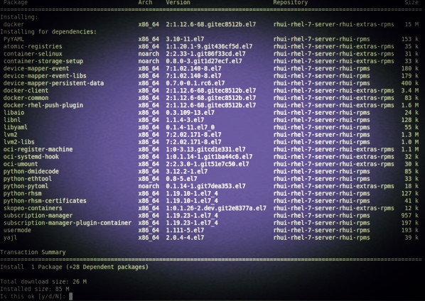](https://www.cyberciti.biz/media/new/faq/2018/01/Install-Docker-on-RHEL-7-using-yum-command.jpg)

**How to install Docker CE on CentOS 7 (method 2)**

First remove older version of docker (if any):  
$ sudo yum remove docker docker-common docker-selinux docker-engine-selinux docker-engine docker-ce  
Next install needed packages:  
$ sudo yum install -y yum-utils device-mapper-persistent-data lvm2  
Configure the docker-ce repo:  
$ sudo yum-config-manager --add-repo https://download.docker.com/linux/centos/docker-ce.repo

|  |
| --- |
| Loaded plugins: fastestmirror  adding repo from: https://download.docker.com/linux/centos/docker-ce.repo  grabbing file https://download.docker.com/linux/centos/docker-ce.repo to /etc/yum.repos.d/docker-ce.repo  repo saved to /etc/yum.repos.d/docker-ce.repo |

Finally install docker-ce:  
$ sudo yum install docker-ce  
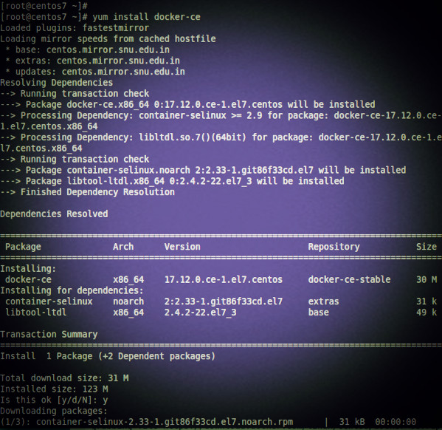

**How to enable docker service**

$ sudo systemctl enable docker.service